**ASSIGNMENT-4**

**Docker and Kubernetes**

|  |  |
| --- | --- |
| Assignment Date | 23rd Oct 2022 |
| Student Name | S. Gitanjali |
| Team ID | PNT2022TMID25979 |
| Maximum Marks | 2 Marks |

1. Pull an image from Docker hub and run it in Docker playground

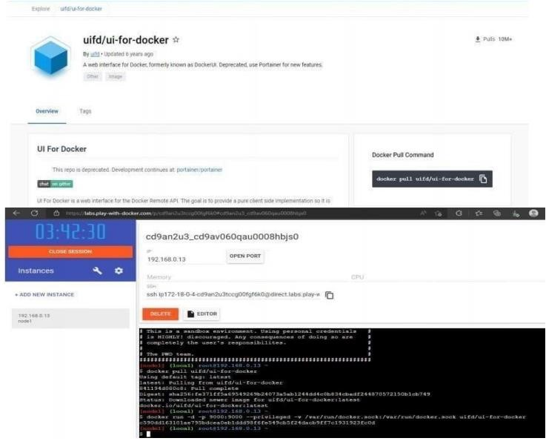

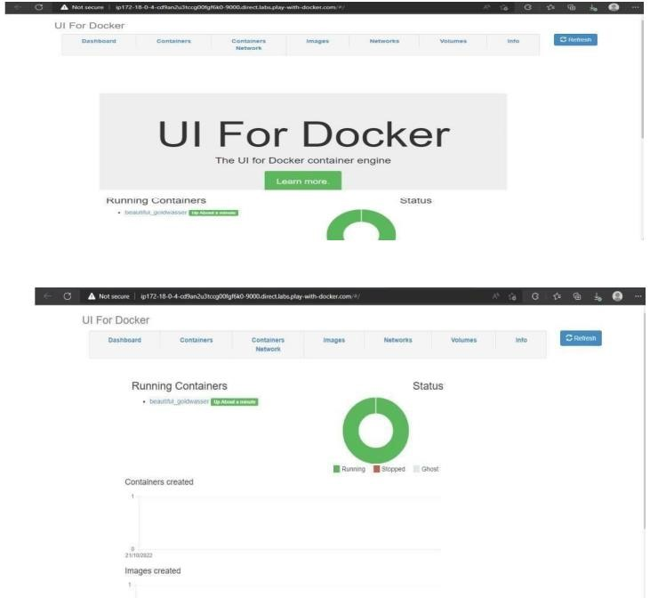

1. Create a Docker file for the Job portal application and deploy it in Docker desktop application:

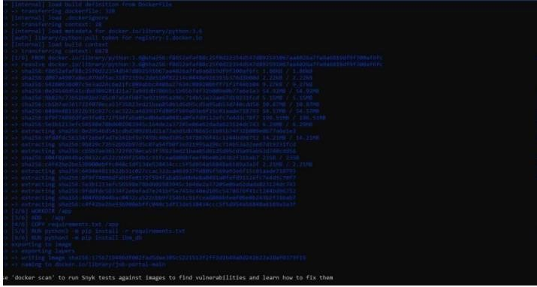

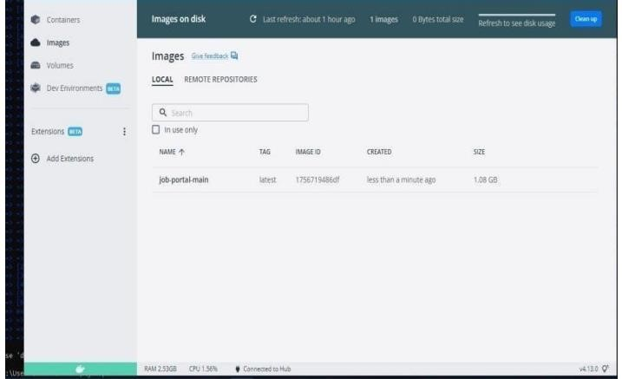

1. Create a IBM container registry and deploy Hello world app or Job portal app:

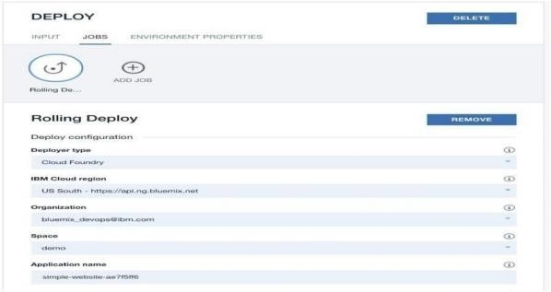

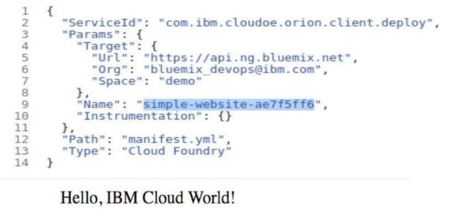

1. Create a Kubernetes cluster in IMB cloud and deploy Hello world image or job portal image and also expose the same app to run node port

